
QUALITY ALERT

Customer: EZ PVC - AmeriLux Date: May 31, 2022
Die: 15191 / 15192 Colour: ALL
Type of Complaint: EZ PVC - AmeriLux REJECETED

Q.A # Q.I.R # CUSTOMER NCR #

Description: Customer REJECTED panels have the DIMPLES on top visible surface
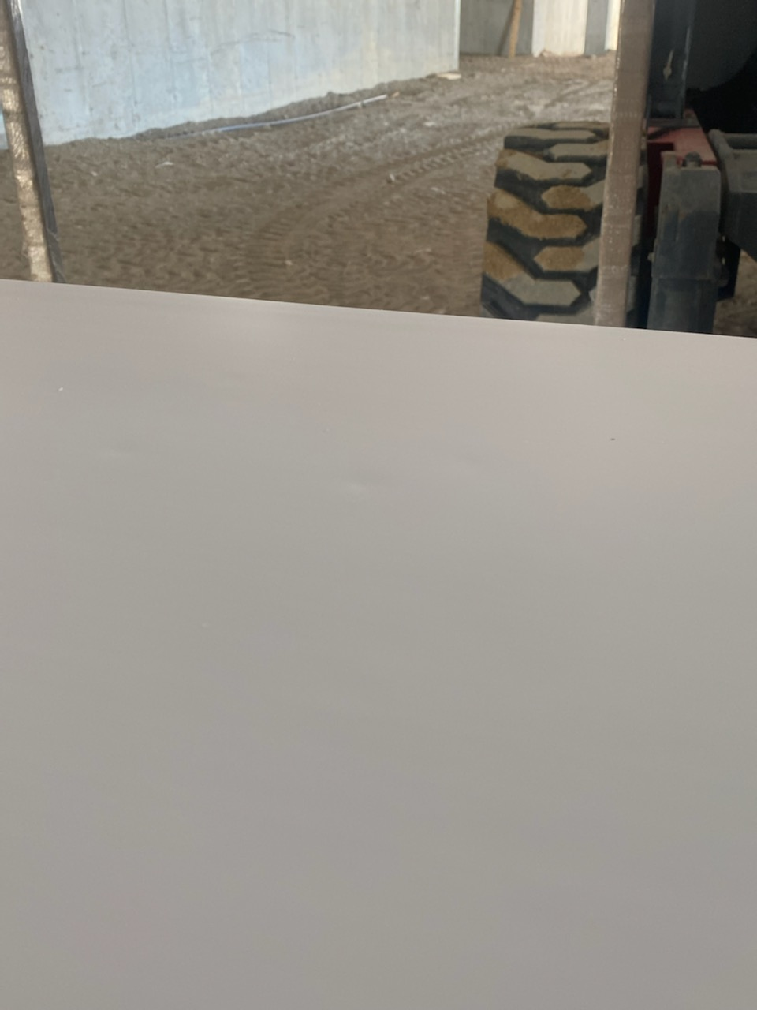
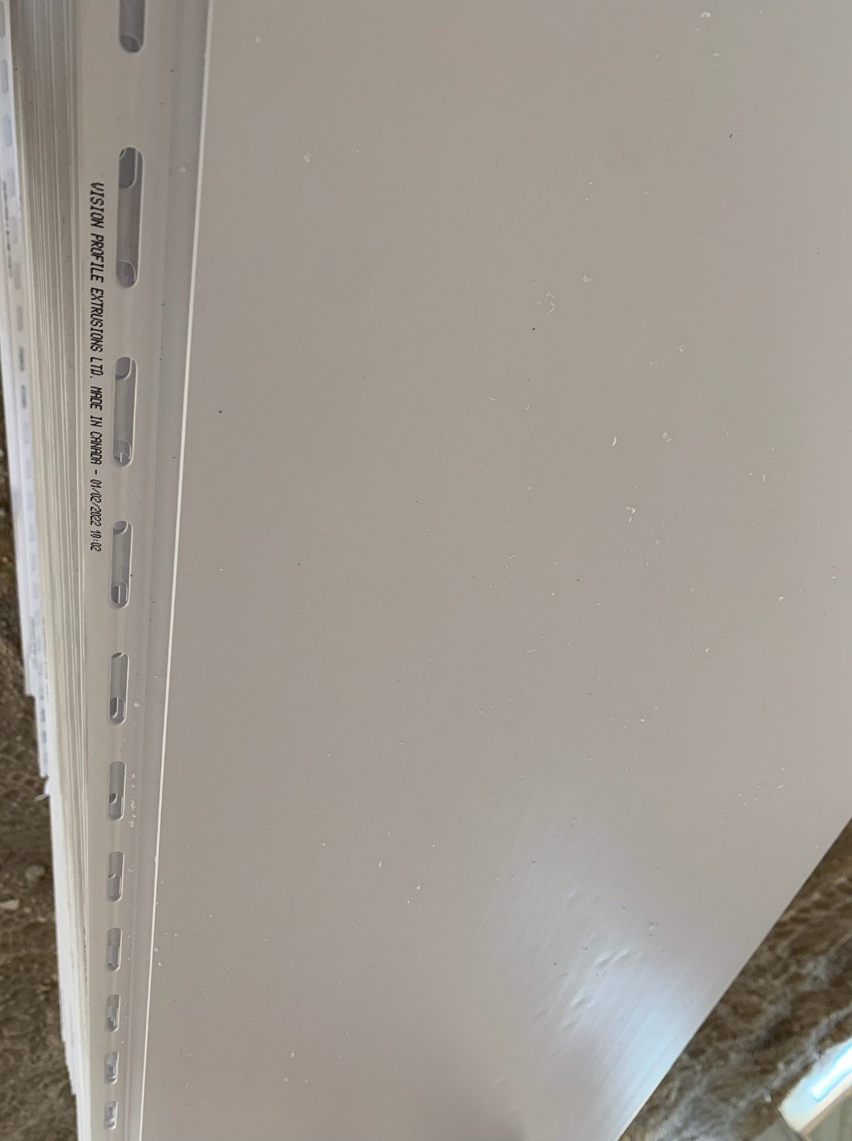
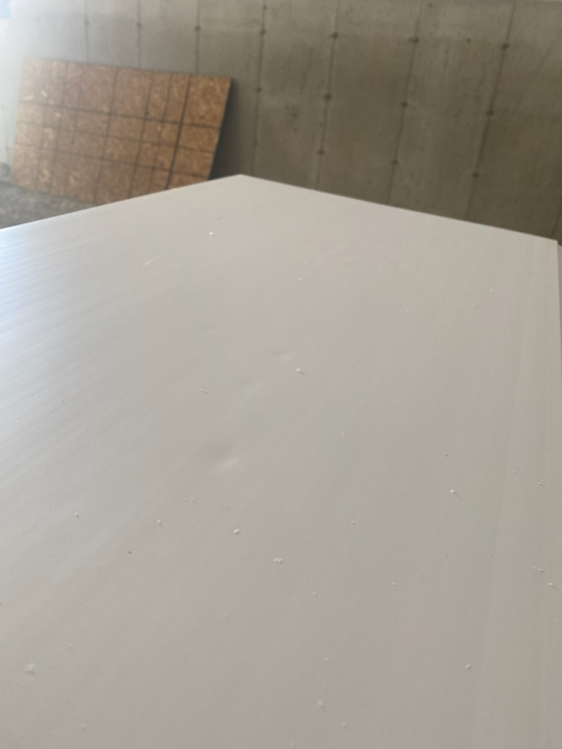

THE DIMPLES ABOVE ARE NOT ACCEPTABLE
BY SIGNING BELOW, YOU ACKNOWLEDGE THE PROBLEM ABOVE AND AGREE TO MONITOR THIS ISSUE IN FUTURE PRODUCTION RUNS.
DAY SHIFT |  | AFTERNOON SHIFT |  | NIGHT SHIFT
NAME | SIGNATURE | NAME | SIGNATURE | NAME | SIGNATURE

